TECHNICAL PROJECT REPORT

# Title of Invention / Project:

**Bluepro Modular Smart_Watch.**

# Team Members / Inventors:

|  |  |  |  |  |  |
| --- | --- | --- | --- | --- | --- |
| **S. No.** | **Name** | **Department** | **Designation** | **Mobile** | **E-Mail** |
| 1. | Himanshu | CSE(IOT) | Student | 9138504583 | Himanshubatra256@gmail.com |
| 2. | Archit Jain | CSE(IOT) | Student | 9354711000 | Architjain012345@gmail.com |
| 3. | Deepika | CSE(IOT) | Student | 7404709525 | Deepikamarwaha09913@gmail.com |
| 4 | Khushal Thakur | ECE | Mentor | 9646030764 | khushal.thakur@cumail.in |
| 5. | Anshul Sharma | ECE | Mentor | 9478697475 | anshulsharma.ece@cumail.in |
| 6 | Kiran Jot Singh | ECE | Mentor | 9463909689 | kiranjotsingh.ece@cumal.in |
| 7. | Divneet Singh Kapoor | ECE | Mentor | 9878422653 | divneet.ece@cumail.in |

Section – 1 (IPR Related)

# Brief Abstract:

There are times when you are with your smartphone receiving a call but being on silent you would not be able to know about the call or the text you received. This is although a very simple and usual problem but some time it can create a great chaos.

In a situation like that you can get notified about the text and the call you receiving and you can ignore if it’s not you can contact them when you are free. So that you are notified by the watch that you are getting any call or text and the same time it is acting as a watch too by displaying time and date itself from the smartwatch with which it is connected.

We can modify the android application later on for some extra modifications like adding some health related sensors. Also being a compatible watch it is also platform independent. Also this watch triggers that limited market full of those geeks who are always interested in modification and as the code is available online free of cost it would be easy for them to make that modification happen.

# Existing state-of-the-art and Drawbacks in existing state-of-the-art

Existing is the tech which can preform the time display functionality but with our smartwatch there opens a whole new window to compatibility that we can modify the android application later on for some extra modifications like adding some health related sensors. Also being a compatible watch it is also platform independent.

|  |  |  |
| --- | --- | --- |
| **S. No.** | **Existing state of art** | **Drawbacks in existing state of art** |
| 1. | USD754356S1  Samsung Smart band | Its is less modular like if you some how manages to  Open the band you will still not be able to add any third party parts like upgrading any sensor. |
| 2. | USD781852S1  Anhui Huami IT  Activity tracker | It also do suffers with the same problem but also it is not available in the market easily. |
| 3. | USD794012S1  Sony Corporation  Wearable device | Also having the same of that not being modular it is also not justified clearly about the device as it is given as on the website as wearable device. |
| 4. | USD636686S1  Nike edition apple watch | Apple watch being an apple product its is only compatible with an apple iphone ,you can use the watch without an iphone but the initial setup is impossible without an iphone so it can be catagoriesed as PLATFORM DEPENDENT. |

# Novel/Additional modifications that you can propose to improve upon drawbacks

*(List down the features)*

* Platform Independent(App for both iOS & android). Being an open source project it is very easy for everyone to make an application for both android or ios also the app is available online on the given link.Other watches being brand oriented they are tied in their own set of criteria (s). So this Watch can be on the heavy side as its functions are not only limited to the operating system.
* Modular(can be modified when needed).

It is modular in such a way that it opens a wide range of possibilities that at the extra edge you can add some sensors module (like heart rate sensor, fingerprint sensor ) which are cheap in price and come in handy to convert this notification oriented smart watch into an fitness watch.

* Price wise if you consider the watches available in the market this watch can be re-build with some premium material in less than the quarter of the watches available currently.So it is safe to assume it as an pocket friendly watch.

# Advantages

(*List down the advantages, if each feature is incorporated)*

* Great Standby time.As mentioned BEING MODULAR adding a premium battery will increase the stand-by time of the watch.
* Future Possibilities (Upgradable with extra sensors),also can be a full on device that can be an smartwatch and an activity sensor also being a health watch at the same time.
* It is also Pocket friendly as if you smone how damage the watch the repair would be relatively easy and would also be pocket friendly as the replacement parts are available online and are realatively cheap.

# Block Diagram

LCD

Micro controller/

micro processor

Bluetooth client (Watch)

Bluetooth server.

(Smartphone)

Section – 2 (Real Project)

# Materials

1. Arduino pro mini /Arduino Nano.

The detailed **specification** of the **Arduino Nano** board is as follows: Microcontroller ATmega328. Operating Voltage (logic level): 5 V. Input Voltage (Recommended): 7-12 V.

1. HC05 bluetooth module.

Speed: Asynchronous: 2.1Mbps(Max) / 160 kbps, Synchronous: 1Mbps/1Mbps. Security: Authentication and encryption. Profiles: Bluetooth serial port. Power supply: +3.3VDC 50mA.

1. 5v charging module.

Micro USB *5V* 1A Lithium Battery *Charger* with Protection. Product 9/10 ... This tiny *module* is perfect for *charging* single cell 3.7V 1 Ah or higher LiPo cells such as 16550s that don't have their own protection circuit.

1. 3.7v(3.3v) lithium polymer battery.

*3.3 V Battery* Management are available at Mouser Electronics.

1. St7735 1.8 inch coloured display.

This *1.8inch* TFT module's input voltage: 5V / 3.3V. Dot matrix: 128 x 160. Driver IC: ... *ST7735*. Pin definition: 1-RST, 2-CE, 3-D/C, 4-DIN, *5*-CLK, 6-UCC, 7-BL, 8-GND. ... Normally, the chip is Samsung *ST7735*.

# Circuit Diagram:-

This circuit diagram is made from circuito.io

Display connection is Through the following schematics:-

ST7735 TFT SPI display pins for Arduino Uno/Nano:

* LED = 3.3V

* SCK = 13

* SDA = 11

* A0 = 8

* RESET = 9

* CS = 10

* GND = GND

* VCC = 5V

# this looks slightly different but you can take refference from above sketch and the connect the circuit by taking care of the circuit completion part.

# Steps of Circuit Completion

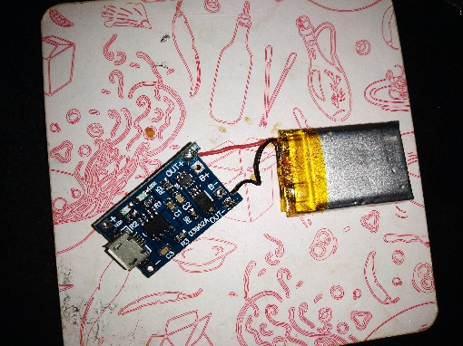Step 1:connect the charging module and the battery an test if they are working or not.

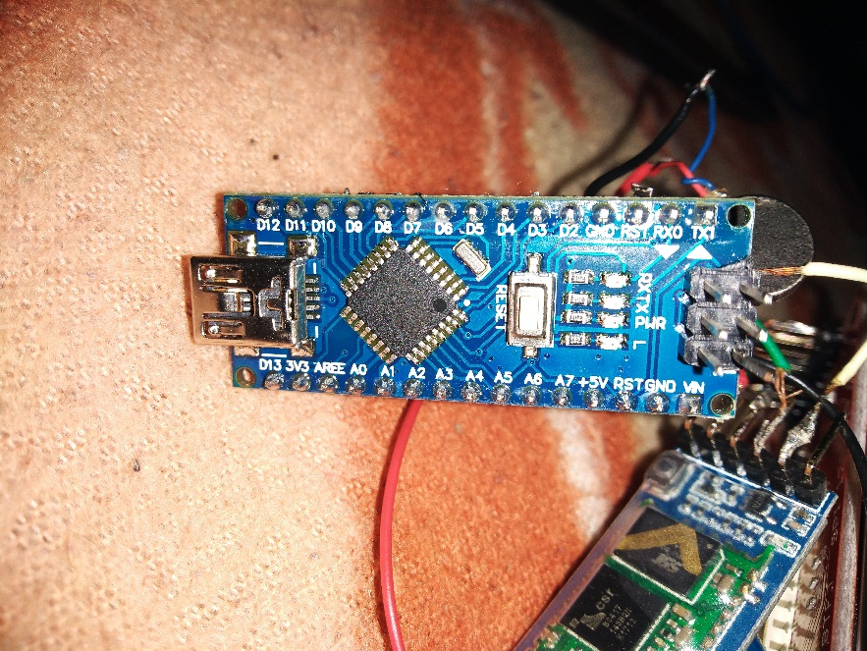Step 2:connect the lcd to Arduino and run the code.

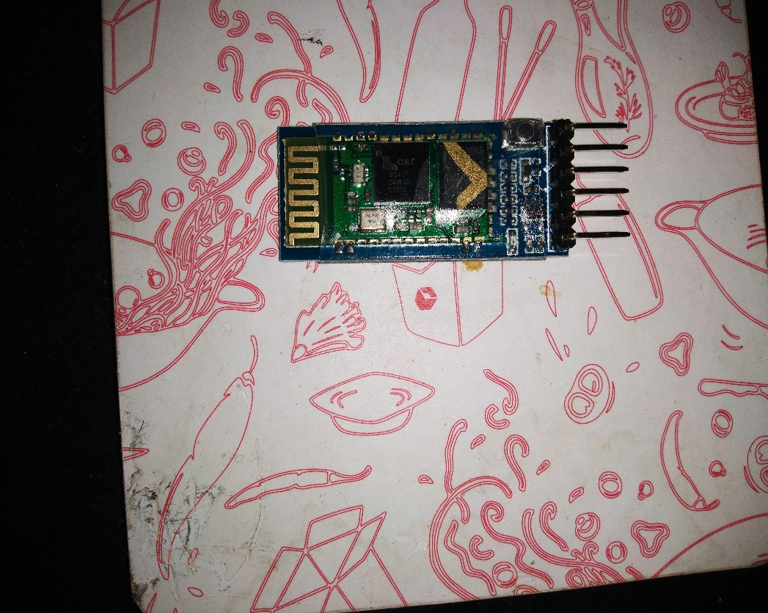step 3.: Connet the Bluetooth as show in the sketch.

Step4: Connet the battery ang charging module.

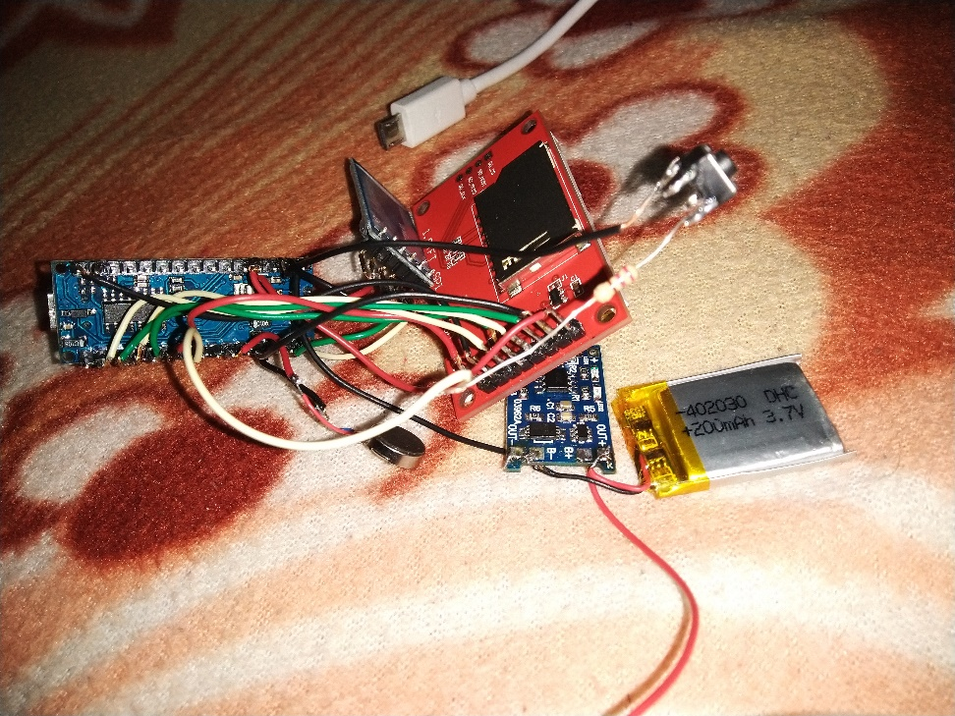Step 5: Assemble the watch according to your taste.

# Program Code

Github link:-

https://github.com/himanshubatra256/Bluepro